SOCIAL MEDIA ANALYSIS
Objective Answers
Q1. Are there any tables with duplicate or missing null values? If so, how would you handle them?
Answer: There are not any duplicates or NULL values in any of the tables.
To check if there are any, I will use the following query:
--to check for NULL values
SELECT * FROM Table_Name
WHERE Column1 IS NULL
OR Column2 IS NULL;
--to check for duplicates
SELECT Column1,Column2, COUNT(*) AS cnt FROM Table_Name
GROUP BY Column1,Column2
HAVING COUNT(*)>1;

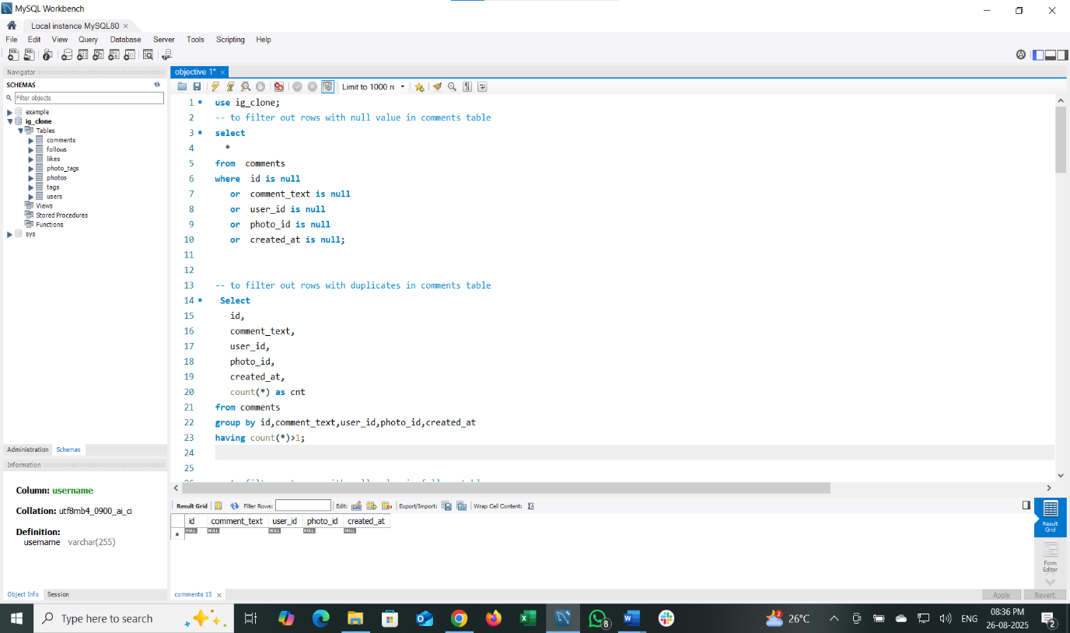

If there are any NULL values, we can update the data with default values. For duplicates, we can delete the duplicate row, keeping only one unique record.
--updation syntax
UPDATE Table_name
SET Column= “Default_value”
WHERE Column IS NULL;

--deleting duplicate records
DELETE t1
FROM table_name t1
INNER JOIN table_name t2
ON t1.column1 = t2.column1
AND t1.column2 = t2.column2
AND t1.id > t2.id; -- keeps the row with the smallest id

Q2. What is the distribution of user activity levels (e.g., number of posts, likes, comments) across the user base?
Answer:
The distribution of user activity levels across the user base was calculated by considering the total number of posts, likes, and comments for each user. Users were then categorized as follows:
- Inactive: 0 total activity (posts + likes + comments)
- Low: 1–10 total activity
- Medium: 11–50 total activity
- High: Above 50 total activities
Based on the analysis:
- 77 users fall into the High activity category.
- 13 users are Inactive with no activity recorded.
- 8 users have Low activity.
- 2 users fall into the medium activity range.
This shows that the majority of users are highly active, while a smaller group remains inactive or only moderately engaged.
SQL QUERY:
SELECT activity_level, COUNT(*) AS user_count FROM (
SELECT sub.id AS user_id,
CASE
WHEN (post_count + like_count + comment_count) = 0
THEN 'Inactive'
WHEN (post_count + like_count + comment_count) <= 10
THEN 'Low'
WHEN (post_count + like_count + comment_count) <= 50
THEN 'Medium'
ELSE 'High'
END AS activity_level
FROM (
SELECT u.id,
COALESCE(COUNT(DISTINCT p.id),0) AS post_count,
COALESCE(COUNT(DISTINCT l.photo_id),0) AS like_count,
COALESCE(COUNT(DISTINCT c.id),0) AS comment_count
FROM users u
LEFT JOIN photos p ON u.id = p.user_id
LEFT JOIN likes l ON u.id = l.user_id
LEFT JOIN comments c ON u.id = c.user_id
GROUP BY u.id
) sub
) t
GROUP BY activity_level
ORDER BY user_count DESC;

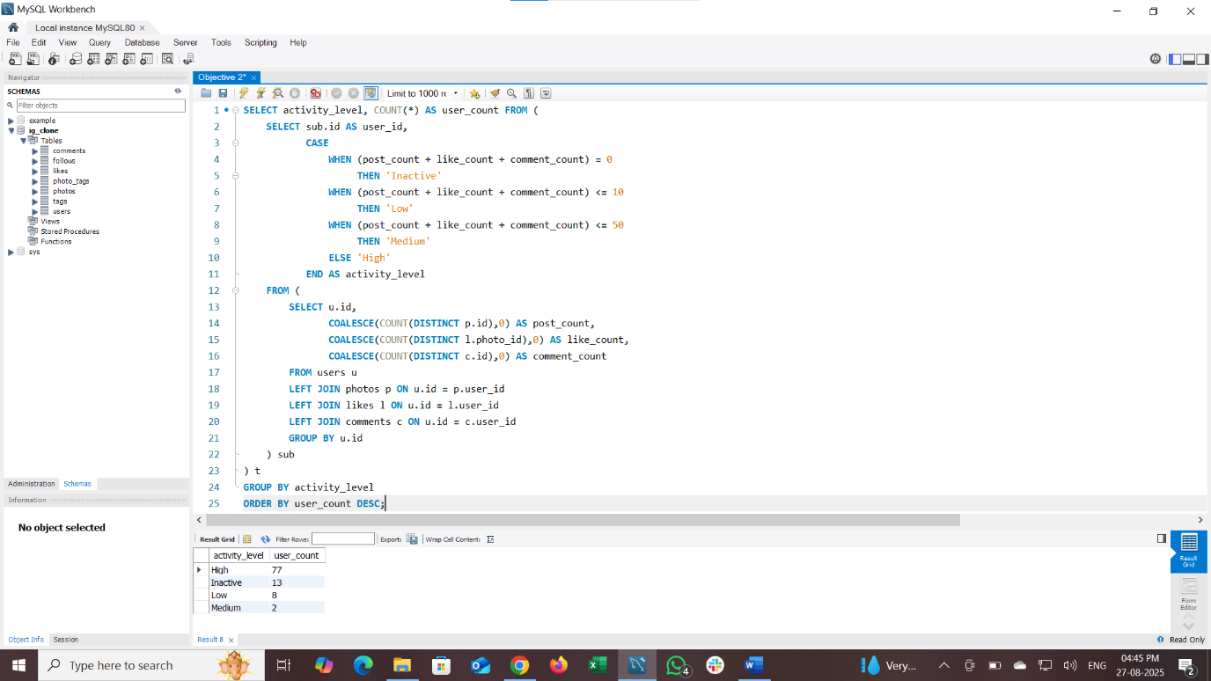

Q3. Calculate the average number of tags per post (photo_tags and photos tables).
Answer: The average number of tags per post is 2.64.
To calculate this, we join photos table and photo tags table based on common column (i.e. photo id from photo tags and id from photos table)
And we grouped the data by photo id and calculate the total count of tag id and again calculate the average of it and finally round the total count to 2 decimal values.
SQL Query:
SELECT
ROUND(AVG(tag_count),2) AS avg_tags_per_post
FROM (
SELECT
pt.photo_id,
COUNT(pt.tag_id) AS tag_count
FROM photo_tags pt
JOIN photos p ON p.id = pt.photo_id
GROUP BY pt.photo_id
) AS photo_tag_counts;
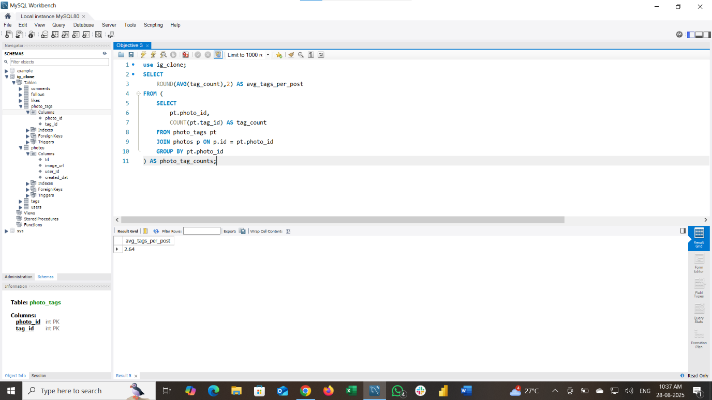

Q4. Identify the top users with the highest engagement rates (likes, comments) on their posts and rank them.
Answer:
To calculate this, we left join users table with photos, likes, and comments table based on common column (as there might be users who haven’t like or post or comment on any post uploaded). Then we group the data based on user id and username and calculate the count of likes, comments for each user and add those values to use as engagement score and rank the users based on the engagement score (higher the engagement score, lower the rank).
Here are top 10 users with the highest engagement:
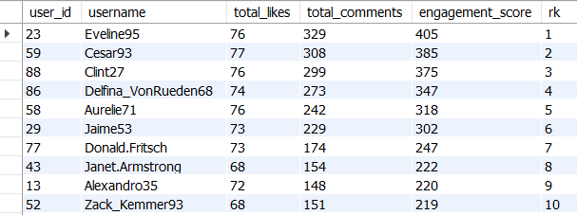

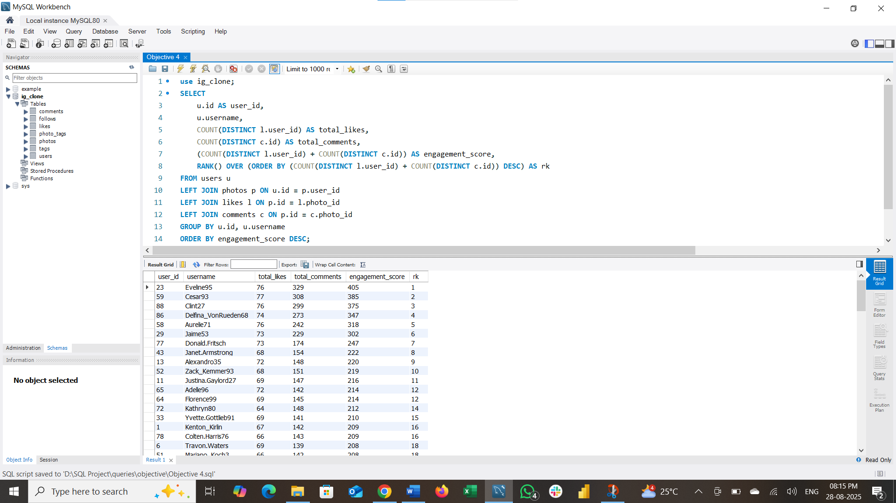

Q5. Which users have the highest number of followers and followings?
Answer:
To calculate this, we left join users table with follows table based on common column and group the data for each user and calculate the total count of followee and rank the users based on followee count (higher the followee count, lower the rank) and select only those users who have the highest followee count. (rank=1)
There are top 77 users with highest number of followings.
10 of those users are:
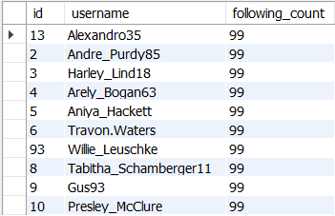

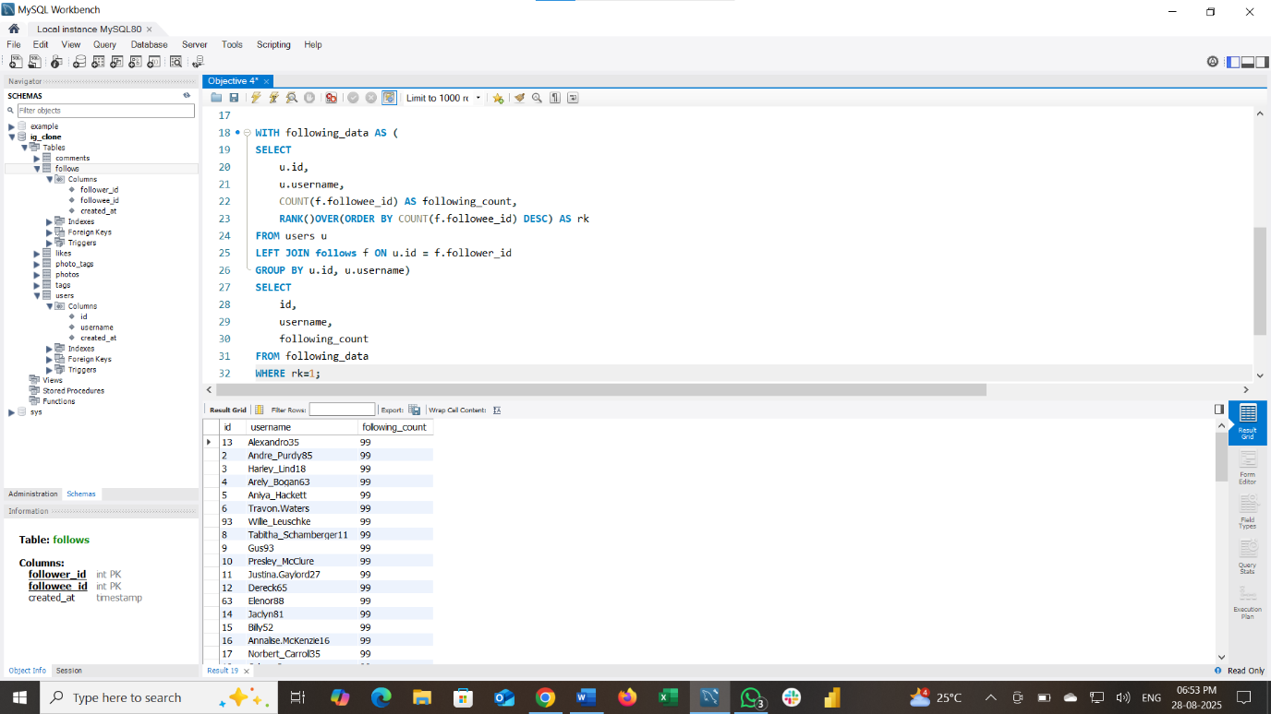

To calculate this, we left join users table with follows table based on common column and group the data for each user and calculate the total count of follower and rank the users based on follower count (higher the follower count, lower the rank) and select only those users who have the highest follower count. (rank=1)
There are 23 records sharing same highest number of followers.
Here are 10 of those users from the above output:
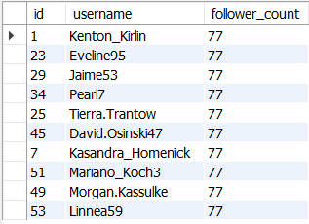

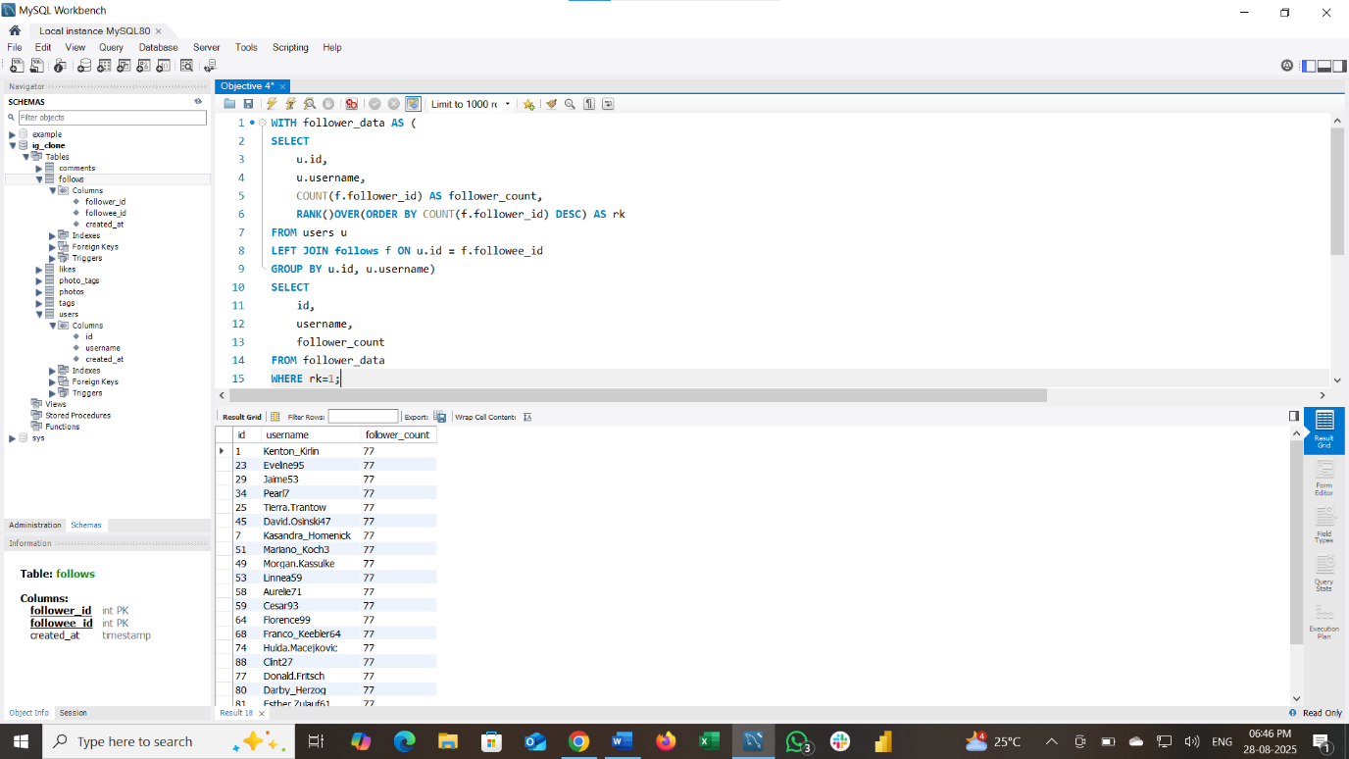

Q6. Calculate the average engagement rate (likes, comments) per post for each user.
Answer:
To calculate this, we first left join users table with likes, comments and photos tables based on common column and group the data for each user and calculate count of likes and comment they made and add those values and use it as total engagement, and also we calculate number of post uploaded for each user and divide the total engagement by number of post for each user to get the average engagement per post and round the value into 2 decimal place.
Here is a glimpse of average engagement rate per post for each user.
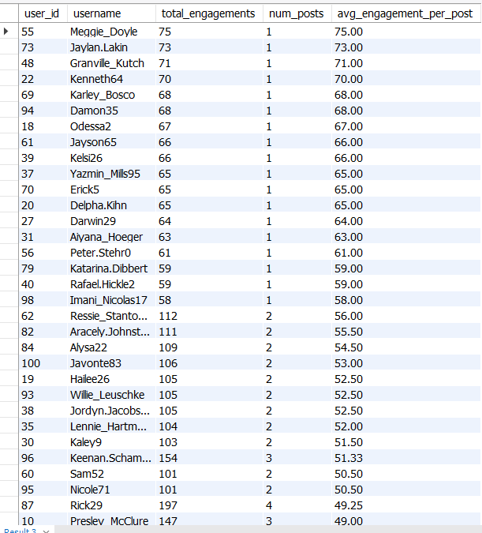
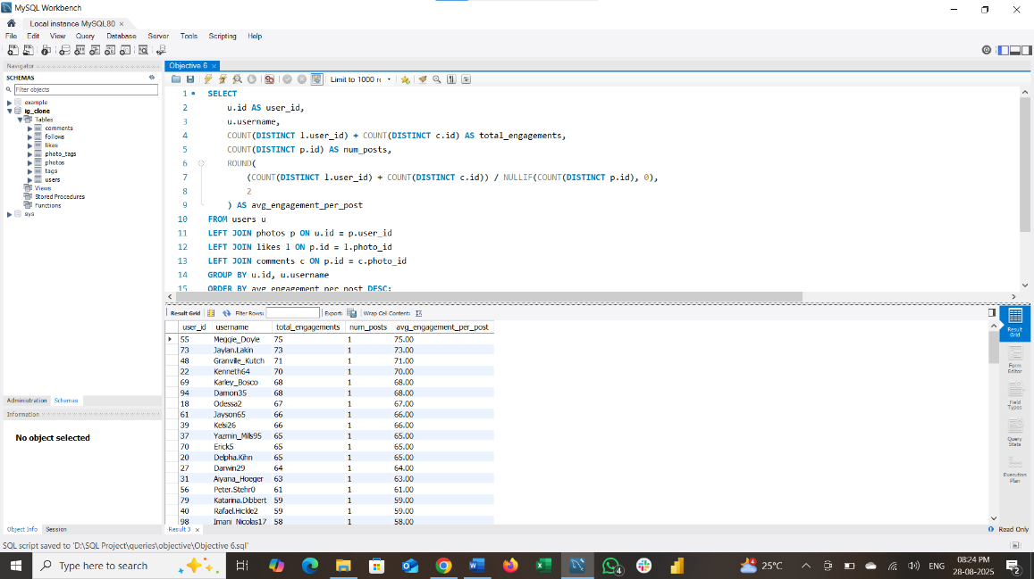

Q7. Get the list of users who have never liked any post (users and likes tables).
Answer:
To calculate this, we first left join users table with likes table based on common column (id from users table and user id from likes table). And filter out the users where their value of user id in likes table(l.user_id) after left joining is null.
Here is the list of users who have never liked any post.
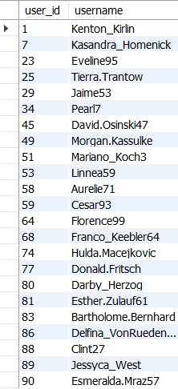
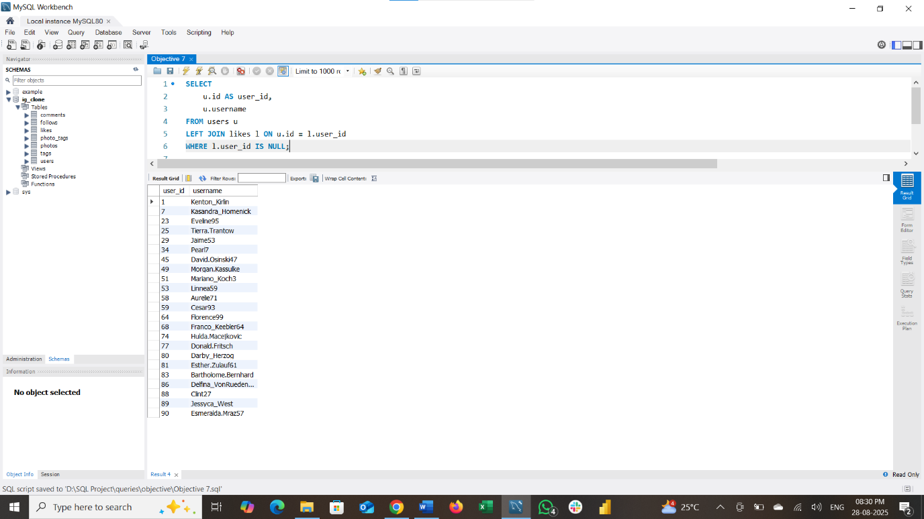
Q8. How can you leverage user-generated content (posts, hashtags, photo tags) to create more personalized and engaging ad campaigns?
Leveraging User-Generated Content (UGC) for Ads
We calculate average engagement per post for each hashtags used to find out which one is most popular and which one is not.
SQL QUERY:
SELECT
t.tag_name,
AVG(photo_engagement.total_likes + photo_engagement.total_comments) AS avg_engagement_per_photo
FROM (
SELECT
p.id AS photo_id,
COUNT(DISTINCT l.user_id) AS total_likes,
COUNT(DISTINCT c.id) AS total_comments
FROM photos p
LEFT JOIN likes l ON p.id = l.photo_id
LEFT JOIN comments c ON p.id = c.photo_id
GROUP BY p.id
) AS photo_engagement
JOIN photo_tags pt ON photo_engagement.photo_id = pt.photo_id
JOIN tags t ON pt.tag_id = t.id
GROUP BY t.tag_name
ORDER BY avg_engagement_per_photo DESC:

INSIGHTS:
- Tags related to food ("delicious," "foodie," "food") have very high engagement, indicating strong user interest in food-related content.
- More niche or lifestyle tags like "hair," "concert," "fashion" also register notable engagement but slightly lower.
RECOMMENDATION:
- Focus content creation on food and visually appealing themes, as these have shown to drive the most engagement.
- Avoid overusing low-engagement or generic tags, instead focus on specific high-engagement ones.

Q9. Are there any correlations between user activity levels and specific content types (e.g., photos, videos, reels)? How can this information guide content creation and curation strategies?
Steps to analyse user activity levels and correlate with specific content types (photos with tags)
Step 1: Get total likes and comments per photo
This shows engagement per photo by likes and comments.
Step 2: Get tags for each photo to understand content types/themes
This maps each photo to its tags (content themes/subjects).
Step 3: Combine engagement and tags to see which tags get more engagement
This reveals which content tags attract the most engagement.
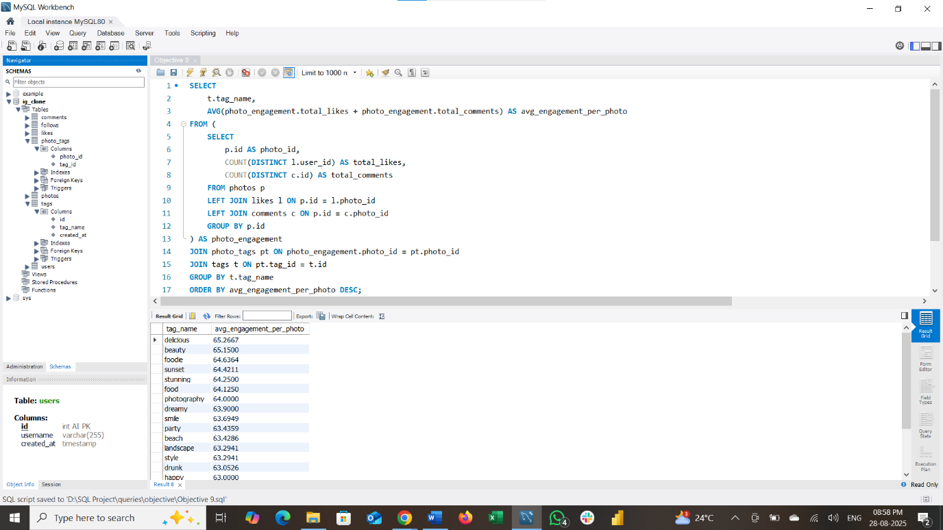

INSIGHTS:
- Tags related to food ("delicious," "foodie," "food") have very high engagement, indicating strong user interest in food-related content.
- Visual and aesthetic tags ("beauty," "sunset," "stunning," "photography," "landscape," "style") also show high engagement, suggesting that users are highly responsive to visually pleasing or artistic content.
- Tags expressing emotions or experiences ("happy," "fun," "smile," "party," "dreamy") attract good engagement, highlighting the importance of connecting emotionally with users.
- More niche or lifestyle tags like "hair," "concert," "fashion" also register notable engagement but slightly lower.
RECOMMENDATION:
- Focus content creation on food and visually appealing themes, as these have shown to drive the most engagement.
- Use tags related to emotions and experiences to add a relatable, human touch that resonates with users.
- Avoid overusing low-engagement or generic tags, instead focus on specific high-engagement ones.

Q10. Calculate the total number of likes, comments, and photo tags for each user.
To calculate this, we created at common table expression for calculating total number of likes by left joining photos table and likes table based on common column and group the data for each user and count the total number of likes for each user,
Similarly, we do the same procedure for comments and tags and finally combine those common table expressions to generate the final output (i.e. total number of likes, comments, and photo tags for each users).
SQL query:
WITH Likes_CTE AS (
SELECT
p.user_id,
COUNT(l.user_id) AS total_likes
FROM photos p
LEFT JOIN likes l ON p.id = l.photo_id
GROUP BY p.user_id
),
Comments_CTE AS (
SELECT
p.user_id,
COUNT(c.id) AS total_comments
FROM photos p
LEFT JOIN comments c ON p.id = c.photo_id
GROUP BY p.user_id
),
Tags_CTE AS (
SELECT
p.user_id,
COUNT(pt.tag_id) AS total_photo_tags
FROM photos p
LEFT JOIN photo_tags pt ON p.id = pt.photo_id
GROUP BY p.user_id)
SELECT
u.id AS user_id,
u.username,
COALESCE(L.total_likes, 0) AS total_likes,
COALESCE(C.total_comments, 0) AS total_comments,
COALESCE(T.total_photo_tags, 0) AS total_photo_tags
FROM users u
LEFT JOIN Likes_CTE L ON u.id = L.user_id
LEFT JOIN Comments_CTE C ON u.id = C.user_id
LEFT JOIN Tags_CTE T ON u.id = T.user_id
ORDER BY u.id;
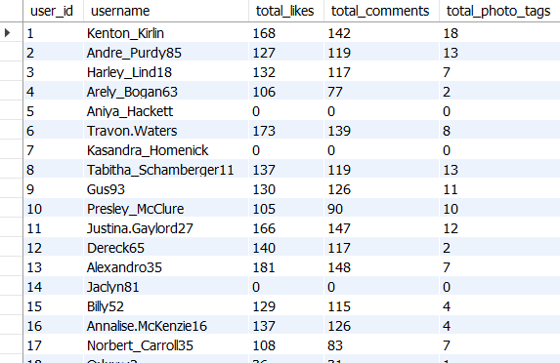

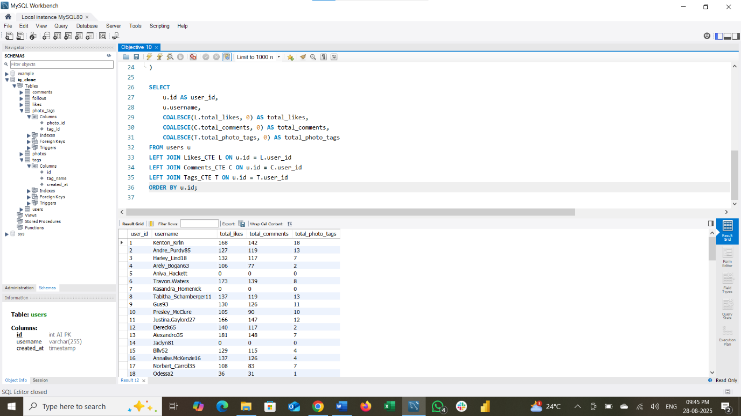

Q11. Rank users based on their total engagement (likes, comments, shares) over a month.
To calculate this,
We create as common table expression to calculate number of total likes and comments and total engagement (likes + comments) for each user and for each month. Finally display the users with their total likes, total comments made over the month. And rank the users based on the engagement over the months (higher the engagement, lower the rank).
SQL Query:
WITH user_engagement AS (
SELECT
p.user_id,
DATE_FORMAT(p.created_dat,"%Y-%m") AS month,
COUNT(DISTINCT l.user_id) AS total_likes,
COUNT(DISTINCT c.id) AS total_comments,
(COUNT(DISTINCT l.user_id) + COUNT(DISTINCT c.id)) AS total_engagement
FROM photos p
LEFT JOIN likes l
ON p.id = l.photo_id
AND date_format(l.created_at,"%Y-%m") = DATE_FORMAT(p.created_dat,"%Y-%m")
LEFT JOIN comments c
ON p.id = c.photo_id
AND DATE_FORMAT(c.created_at,"%Y-%m") = DATE_FORMAT(p.created_dat,"%Y-%m")
GROUP BY p.user_id, DATE_FORMAT(p.created_dat,"%Y-%m")
)
SELECT
ue.user_id,
u.username,
ue.month,
ue.total_likes,
ue.total_comments,
ue.total_engagement,
RANK() OVER (PARTITION BY ue.month ORDER BY ue.total_engagement DESC) AS engagement_rank
FROM user_engagement ue
JOIN users u ON ue.user_id = u.id
ORDER BY ue.month DESC, engagement_rank;

Here are top 10 users:
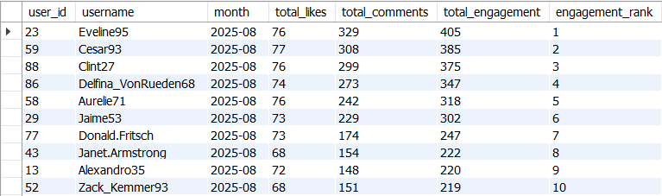
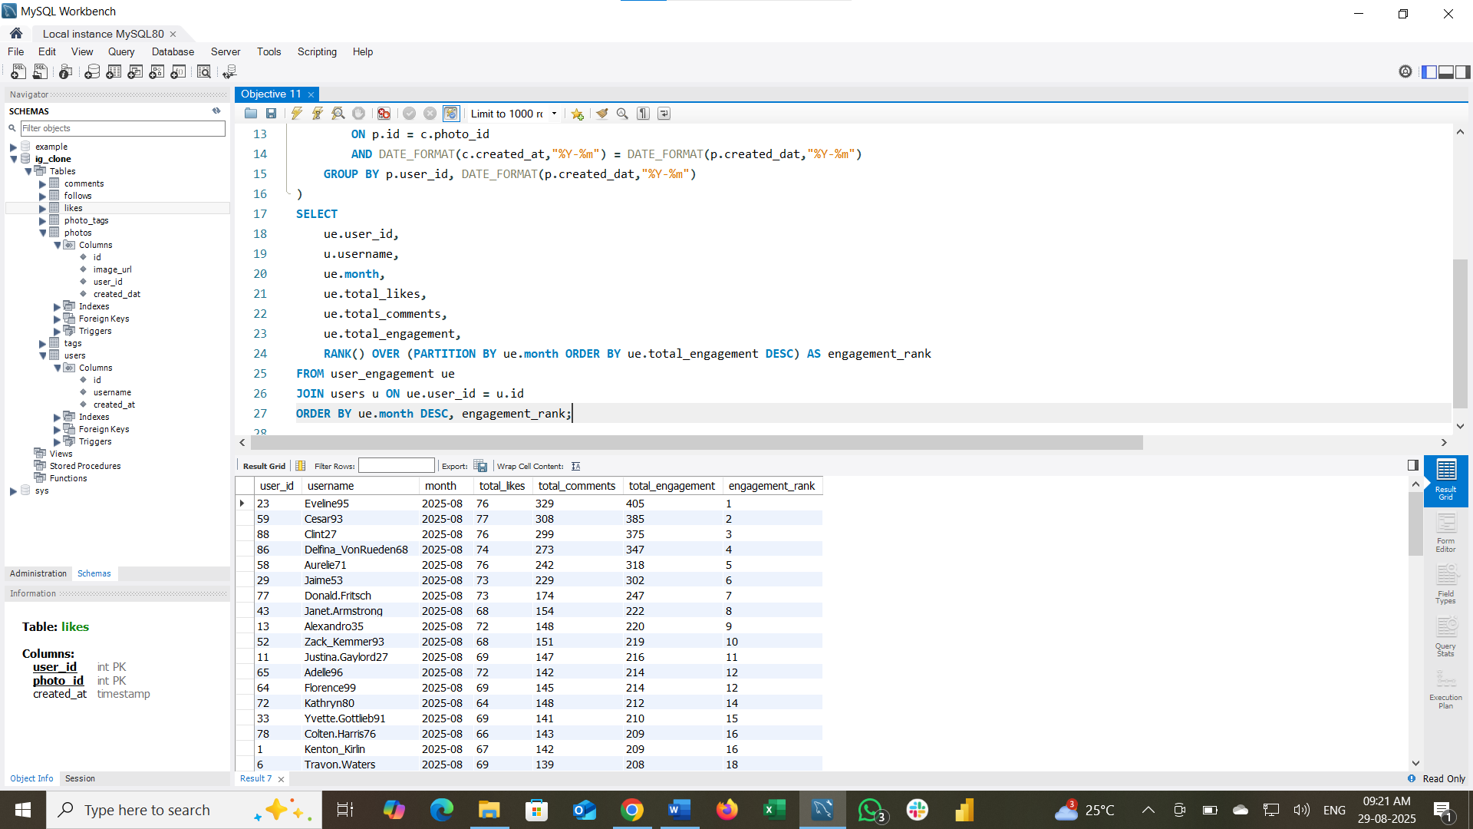

Q12. Retrieve the hashtags that have been used in posts with the highest average number of likes. Use a CTE to calculate the average likes for each hashtag first.
To calculate this,
We create a common table expression to calculate total number of like for each photo get and connect it with the tags link with the photo uploaded, and group the data for each hashtag and calculate the average number of likes per photo. And finally display the tags with its corresponding average likes.
SQL Query:
WITH Hashtag_AvgLikes AS (
SELECT
t.tag_name,
AVG(likes_per_photo.likes_count) AS avg_likes
FROM tags t
JOIN photo_tags pt ON t.id = pt.tag_id
JOIN (
SELECT
p.id AS photo_id,
COUNT(l.user_id) AS likes_count
FROM photos p
LEFT JOIN likes l ON p.id = l.photo_id
GROUP BY p.id
) likes_per_photo ON pt.photo_id = likes_per_photo.photo_id
GROUP BY t.tag_name
)
SELECT
tag_name,
avg_likes
FROM Hashtag_AvgLikes
ORDER BY avg_likes DESC;

Here are some tags with highest average number of likes:
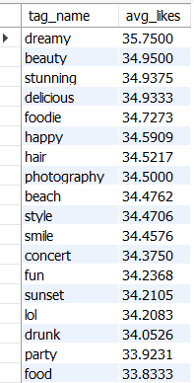
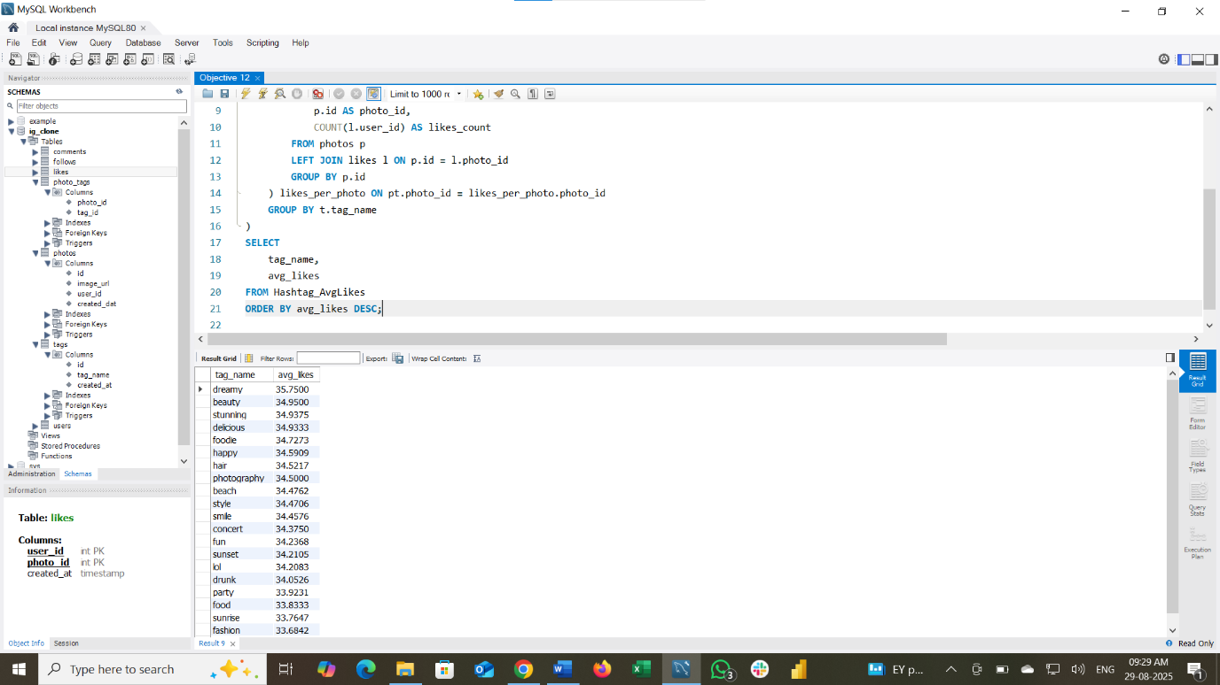

Q13. Retrieve the users who have started following someone after being followed by that person.
To Calculate this,
we self join follows table with itself based on the condition (f1.follower_id=f2.followee_id and f1.followee_id=f2.follower_id) to identify who are the follower and followee. And filter on the condition (f1.created_at > f2.created_at) to identify the users who started following someone after being followed by that person.

SQL Query:
SELECT
f1.follower_id AS user_id,
f1.followee_id AS followed_user_id,
f1.created_at AS followed_time,
f2.created_at AS followed_back_time
FROM follows f1
JOIN follows f2 ON f1.follower_id = f2.followee_id AND f1.followee_id = f2.follower_id
WHERE f1.created_at > f2.created_at
ORDER BY f1.follower_id, f1.created_at;

The is not returning any output because, the timestamps in every record are same.
So, it is impossible to determine which follow happened first using the created_at field alone.

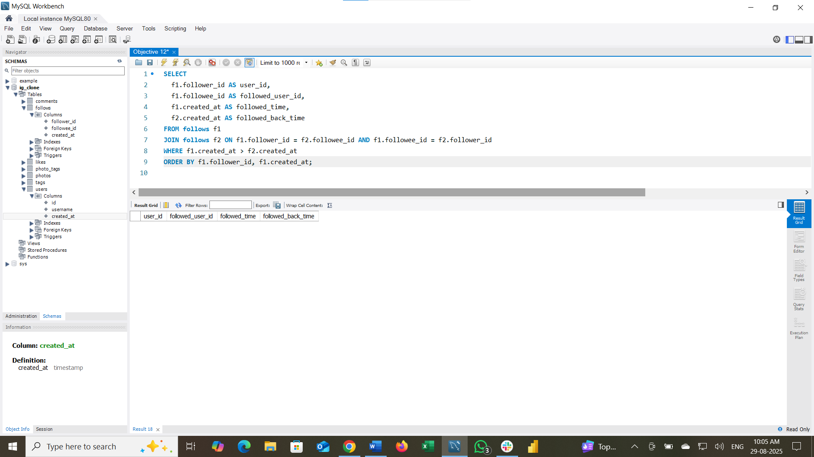

Subjective Answers
Q1. Based on user engagement and activity levels, which users would you consider the most loyal or valuable? How would you reward or incentivize these users?
Step1: Calculate total user engagement per user (posts, likes, comments).
Step2: Rank them based on total engagement score and filter out top 10 users with highest engagement score. These users will be considered as the most loyal and valuable
Step3: Assign reward tiers based on rank as:
- Rank 1 à 'Gold - Exclusive Access + Gifts'
- Rank 2-5 à 'Silver - Discounts + Badges'
- Rank 6-10 à 'Bronze - Recognition + Small Perks'

SQL Query:
WITH User_Engagement AS (
SELECT
u.id AS user_id,
u.username,
COUNT(DISTINCT p.id) AS total_posts,
COUNT(DISTINCT l.user_id) AS total_likes,
COUNT(DISTINCT c.id) AS total_comments,
(COUNT(DISTINCT p.id) + COUNT(DISTINCT l.user_id) + COUNT(DISTINCT c.id)) AS engagement_score
FROM users u
LEFT JOIN photos p ON u.id = p.user_id
LEFT JOIN likes l ON p.id = l.photo_id
LEFT JOIN comments c ON p.id = c.photo_id
GROUP BY u.id, u.username
), Ranked_Users AS (
SELECT
user_id,
username,
total_posts,
total_likes,
total_comments,
engagement_score,
RANK() OVER (ORDER BY engagement_score DESC) AS engagement_rank
FROM User_Engagement
ORDER BY engagement_rank
LIMIT 10) -- Top 10 most engaged users

SELECT
user_id,
username,
engagement_score,
CASE
WHEN engagement_rank = 1 THEN 'Gold - Exclusive Access + Gifts'
WHEN engagement_rank BETWEEN 2 AND 5 THEN 'Silver - Discounts + Badges'
WHEN engagement_rank BETWEEN 6 AND 10 THEN 'Bronze - Recognition + Small Perks'
ELSE 'Standard User'
END AS reward_tier
FROM Ranked_Users;
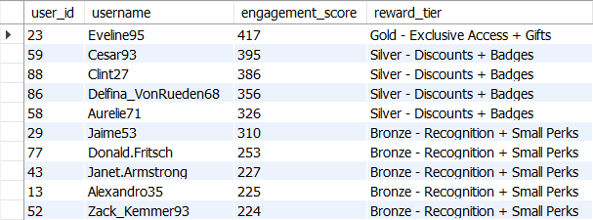
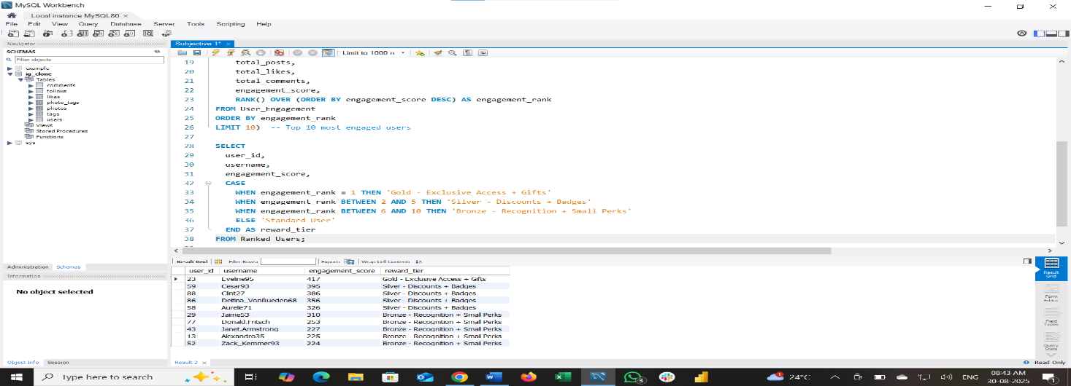

Q2. For inactive users, what strategies would you recommend to re-engage them and encourage them to start posting or engaging again?
First, I filter out inactive users, who haven’t posted any photo, and who haven’t like or comment on any post uploaded.
SQL Query:
SELECT
u.id AS user_id,
u.username
FROM users u
LEFT JOIN photos p ON u.id = p.user_id
LEFT JOIN likes l ON u.id = l.user_id
LEFT JOIN comments c ON u.id = c.user_id
WHERE p.id IS NULL AND l.photo_id IS NULL AND c.photo_id IS NULL;

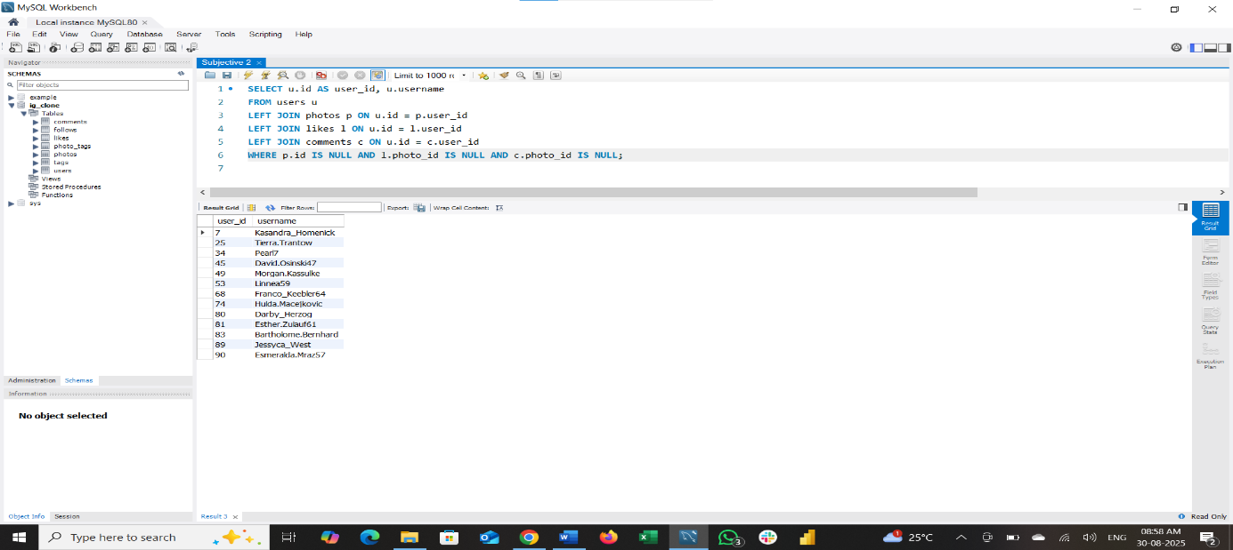

INSIGHTS:
There are 13 users who haven’t posted any photo or liked any posts or commented, which considered them as inactive users.
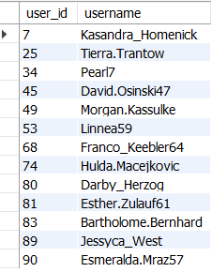

RECOMMENDATION: (To re-engage them and encourage them to start posting or engaging again)
1.Identify Inactive Users
3.Incentivize Return (Offer bonuses, sneak peeks, or exclusive content.)
5.Reward First Action (Give badges, points, or discounts.)
7.Inspire with Peers – (Highlight trending or popular posts from others.)
9.Provide Support – Offer quick help or tips to resolve issues.
2.Personalized Outreach (Remind with emails or push notifications.)
4.Simplify Posting (Provide templates or suggestions for easy content creation.)
6.Gamify Participation (Run contests, challenges, or giveaways.)
8.Personalized Feed – (Show hot topics and relevant interests.)
10.Measure & Optimize – (Track re-engagement and refine strategies.)

Q3. Which hashtags or content topics have the highest engagement rates? How can this information guide content strategy and ad campaigns?
First, we have to find out what are the trending hashtags or topics based on engagements rates.
SQL Query:
WITH Hashtag_Engagement AS (
SELECT
t.tag_name,
AVG(COALESCE(l.likes_count, 0) + COALESCE(c.comments_count, 0)) AS avg_engagement
FROM tags t
JOIN photo_tags pt ON t.id = pt.tag_id
JOIN photos p ON pt.photo_id = p.id
LEFT JOIN (
SELECT photo_id, COUNT(*) AS likes_count
FROM likes
GROUP BY photo_id
) l ON p.id = l.photo_id
LEFT JOIN (
SELECT photo_id, COUNT(*) AS comments_count
FROM comments
GROUP BY photo_id
) c ON p.id = c.photo_id
GROUP BY t.tag_name
)
SELECT tag_name, avg_engagement
FROM Hashtag_Engagement
ORDER BY avg_engagement DESC;

Here is the list of tags based on engagement:

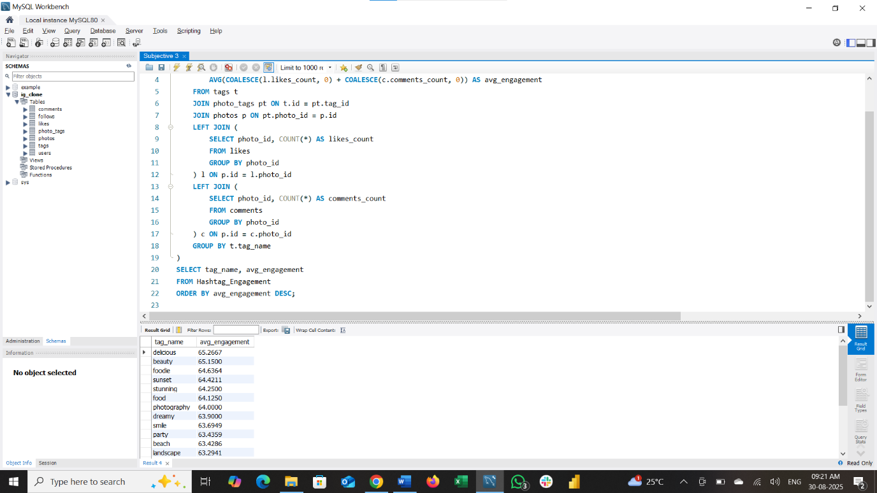

INSIGHTS:
- Food-related tags ("delicious," "foodie," "food") lead with the highest engagement (~64-65), indicating strong user interest in food content.
- Visual and aesthetic tags ("beauty," "sunset," "stunning," "photography," "landscape," "style") also perform very well, reflecting appeal in artistic and scenic content.
- Emotional and social tags ("smile," "party," "happy," "fun," "lol") show healthy engagement, emphasizing the value of relatable, joyful content.
- Lifestyle and fashion tags ("hair," "concert," "fashion") have moderate engagement around 62.5-63, suggesting steady interest in these niches.

RECOMMENDATION:
- Create and promote content focused on highly engaging themes like food and visual beauty to maximize user interaction.
- Use these top hashtags strategically in posts and ads to increase reach and visibility.
- Combine popular tags with emotional or social themes to make content more relatable and shareable.
- Track changes in engagement scores over time to stay updated with evolving trends.
- Design ads around high-performing content topics for better resonance and effectiveness.

Q4. Are there any patterns or trends in user engagement based on demographics (age, location, gender) or posting times? How can these insights inform targeted marketing campaigns?
Since there are not data about user age, location or gender and posting times share the same timestamp, we analyse it based on tags, by calculating count of post, like, comment and engagement rates per each tag.
SQL Query:
WITH Hashtag_Stats AS (
SELECT
t.tag_name,
COUNT(DISTINCT pt.photo_id) AS post_count,
COALESCE(SUM(l.likes_count), 0) AS like_count,
COALESCE(SUM(c.comments_count), 0) AS comment_count,
AVG(COALESCE(l.likes_count, 0) + COALESCE(c.comments_count, 0)) AS avg_engagement
FROM tags t
JOIN photo_tags pt ON t.id = pt.tag_id
JOIN photos p ON pt.photo_id = p.id
LEFT JOIN (
SELECT photo_id, COUNT(*) AS likes_count
FROM likes
GROUP BY photo_id
) l ON p.id = l.photo_id
LEFT JOIN (
SELECT photo_id, COUNT(*) AS comments_count
FROM comments
GROUP BY photo_id
) c ON p.id = c.photo_id
GROUP BY t.tag_name
)
SELECT
tag_name,
post_count,
like_count,
comment_count,
ROUND(avg_engagement,2) AS avg_engagement
FROM Hashtag_Stats
ORDER BY avg_engagement DESC;
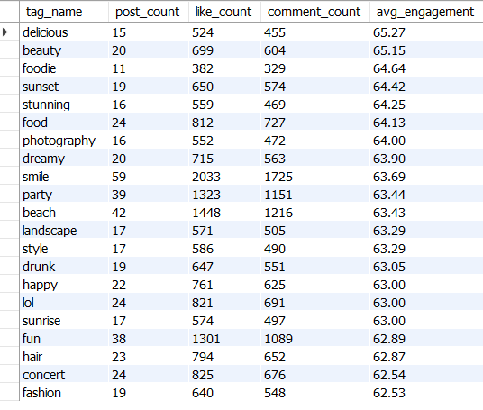
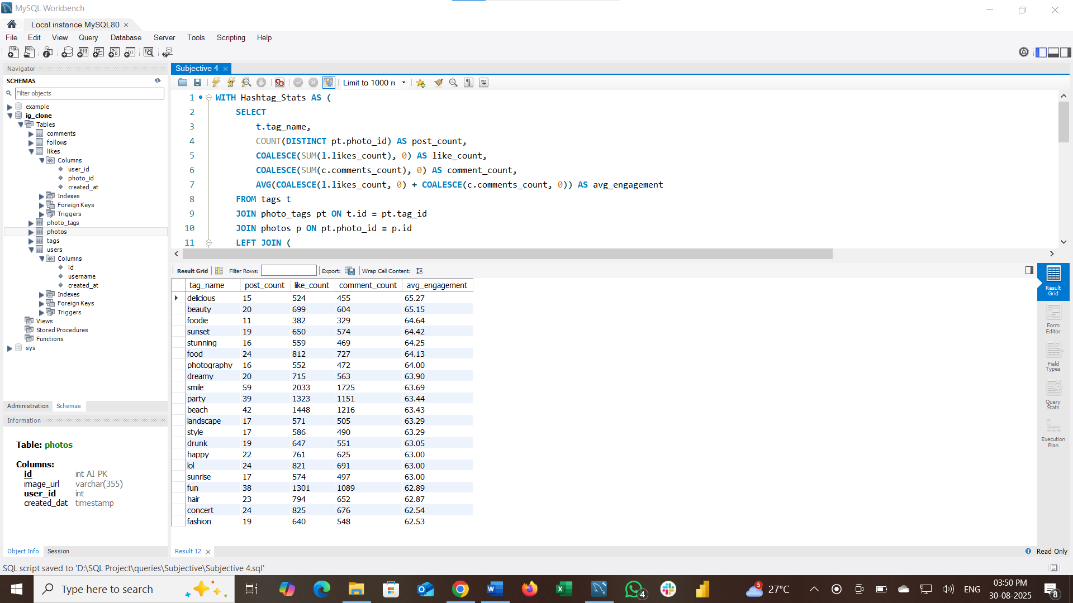

INSIGHTS:
1. Top Performing Hashtags
- Highest Average Engagement:
  - "delicious" (65.27), "beauty" (65.15), "foodie" (64.64), "sunset" (64.42), "stunning" (64.25) lead in engagement rates.
- High Volume Hashtags:
  - "smile," "party," "beach," "fun" have high post, like, and comment counts, showing both popularity and reach.
2. Food and Visual Themes Dominate
- Hashtags related to food ("delicious," "food," "foodie") and visuals/beauty ("beauty," "stunning," "sunset," "photography") consistently rank high, proving their compelling nature for the community.
3. Emotional and Social Tags Are Widely Used
- Tags like "smile," "happy," "party," and "fun" have both high usage and strong average engagement, reflecting user interest in positive, relatable, and social content.
4. Niche and Lifestyle Tags Have Steady Engagement
- While tags like "concert," "drunk," "fashion," "hair" have slightly lower engagement, they maintain decent volume and may cater to specific sub-communities.
RECOMMENDATION:
- Create and promote posts around top-performing hashtags, especially food and visual/aesthetic topics, to maximize user interaction and growth.
- Mix top-volume hashtags with niche lifestyle/emotional tags to reach broader and more targeted audiences.
- Encourage users to use trending hashtags for better visibility and participation.
- Run campaigns centred around the most engaging hashtags for greater conversion rates.
- Use data-driven selection of hashtags in sponsored posts to boost ad ROI.
- Regularly update hashtag analysis to spot emerging topics.
- Suggest high-engagement hashtags to users during posting to help them get discovered, increasing platform-wide engagement.
Q5. Based on follower counts and engagement rates, which users would be ideal candidates for influencer marketing campaigns? How would you approach and collaborate with these influencers?
Ideal candidates for influencer marketing campaigns are users who have highest follower counts and strong engagement rates (many likes, comments per post). These users combine broad reach with active, responsive audiences, making their endorsements impactful.
SQL Query:
WITH Follower_Counts AS (
SELECT
u.id AS user_id,
u.username,
COUNT(f.follower_id) AS follower_count
FROM users u
LEFT JOIN follows f ON u.id = f.followee_id
GROUP BY u.id, u.username
),
Engagement_Rates AS (
SELECT
u.id AS user_id,
AVG(COALESCE(l.likes_count, 0) + COALESCE(c.comments_count, 0)) AS avg_engagement
FROM users u
LEFT JOIN photos p ON u.id = p.user_id
LEFT JOIN (
SELECT photo_id, COUNT(*) AS likes_count FROM likes GROUP BY photo_id
) l ON p.id = l.photo_id
LEFT JOIN (
SELECT photo_id, COUNT(*) AS comments_count FROM comments GROUP BY photo_id
) c ON p.id = c.photo_id
GROUP BY u.id
), rank_on_follower AS (
SELECT
fc.user_id,
fc.username,
fc.follower_count,
er.avg_engagement,
RANK()OVER(ORDER BY fc.follower_count DESC) AS RK
FROM Follower_Counts fc
JOIN Engagement_Rates er ON fc.user_id = er.user_id)

SELECT
user_id,
username,
follower_count,
avg_engagement
FROM rank_on_follower
WHERE RK = 1 AND avg_engagement != 0;

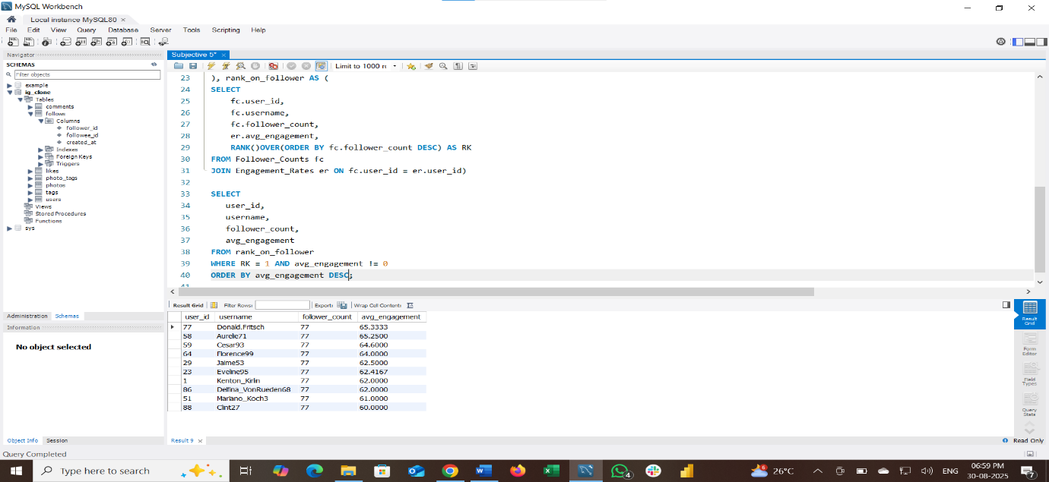

INSIGHTS:
Here is the list of users have the largest audience and proven engagement—ideal for marketing partnerships.
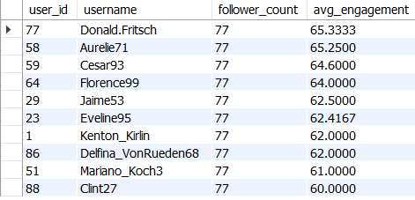
RECOMMENDATION:
- Personalized Outreach: Contact the influencer(s) with tailored proposals, referencing both their follower reach and engagement impact.
- Offer Value: Suggest benefits such as exclusive access, partnerships, or compensation to incentivize collaboration.
- Creative Freedom: Empower influencers with flexibility in content creation for authenticity and better campaign results.
- Long-Term Partnership: Consider ongoing ambassador roles for sustained brand visibility.
- Performance Tracking: Measure influencer campaign effectiveness and refine selection/strategy based on future engagement metrics.

Q6. Based on user behaviour and engagement data, how would you segment the user base for targeted marketing campaigns or personalized recommendations?
First, we segment the users based on engagement score (post, likes, comments) as follows:
- Engagement score > 50 à “Highly Active”
- Engagement score between 11 and 50 à “Moderately Active”
- Engagement score between 1 and 10 à “Inactive or Dormant”
- Engagement score = 0 à”Inactive”
SQL Query:
WITH UserEngagement AS (
SELECT
u.id,
u.username,
COUNT(DISTINCT p.id) AS post_count,
COUNT(DISTINCT l.user_id) AS likes_given,
COUNT(DISTINCT c.id) AS comments_made,
(COUNT(DISTINCT p.id) + COUNT(DISTINCT l.user_id) + COUNT(DISTINCT c.id)) AS engagement_score
FROM users u
LEFT JOIN photos p ON u.id = p.user_id
LEFT JOIN likes l ON u.id = l.user_id
LEFT JOIN comments c ON u.id = c.user_id
GROUP BY u.id, u.username
), Activity_segment AS (
SELECT
id,
username,
engagement_score,
CASE
WHEN engagement_score > 50 THEN 'Highly Active'
WHEN engagement_score BETWEEN 11 AND 50 THEN 'Moderately Active'
WHEN engagement_score BETWEEN 1 AND 10 THEN "Low Active"
WHEN engagement_score = 0 THEN 'Inactive'
END AS activity_segment
FROM UserEngagement)

SELECT
activity_segment,
COUNT(*) AS user_count
FROM Activity_segment
GROUP BY activity_segment;
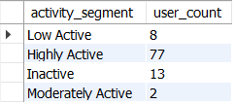

INSIGHTS:
Based on the segmentation, Majority of the users (77) falls into Highly Active segment, followed by Inactive users, and then Low Active and Moderately Active segment.
RECOMMENDATION:
- Focus on nurturing and rewarding Highly active segment via exclusive perks, content creator programs, and brand ambassador roles.
- For inactive user segment, deploy win-back campaigns, personalized notifications, and incentives to reactivate.
- Encourage gradual increase in participation with gamification and tailored content for low active segment.
- Investigate definitions or consider regrouping for better balance for moderately active segment.

Q7. If data on ad campaigns (impressions, clicks, conversions) is available, how would you measure their effectiveness and optimize future campaigns?
To measure ad campaign effectiveness using impressions, clicks, and conversions, focus on these key metrics and strategy:
Click-Through Rate (CTR)
CTR=Clicks/Impressions×100
A high CTR indicates strong ad relevance and audience interest.
Assuming you have tables such as:
- ad_campaigns (id, name, budget, start_date, end_date)
- ad_impressions (ad_campaign_id, user_id, timestamp)
- ad_clicks (ad_campaign_id, user_id, timestamp)
SQL Query:
SELECT
ac.id AS campaign_id,
ac.name,
COUNT(DISTINCT ai.user_id) AS impressions,
COUNT(DISTINCT aclick.user_id) AS clicks,
COUNT(DISTINCT aconv.user_id) AS conversions,
ROUND(COUNT(DISTINCT aclick.user_id) / COUNT(DISTINCT ai.user_id) * 100, 2) AS CTR
FROM ad_campaigns ac
LEFT JOIN ad_impressions ai ON ac.id = ai.ad_campaign_id
LEFT JOIN ad_clicks aclick ON ac.id = aclick.ad_campaign_id
GROUP BY ac.id, ac.name;
How to Use CTR Insights:
CTR Insights
- High CTR Campaigns: Indicate effective ad creative and targeting—can be scaled or studied for best practices.
- Low CTR Campaigns: Signal need for improvement in ad copy, visuals, or audience targeting.

Q8. How can you use user activity data to identify potential brand ambassadors or advocates who could help promote Instagram's initiatives or events?
How to Identify Potential Brand Ambassadors:
- High Post Frequency:
Users who create many posts in the photos table.
- Strong Engagement Received:
Users whose posts receive large counts of likes (likes table) and comments (comments table).
- Influential Network:
Users with a high follower count in the follows table (count where user is the followed_id).
SQL Query:
SELECT
u.id,
u.username,
COUNT(DISTINCT p.id) AS post_count,
COUNT(DISTINCT l.user_id) AS likes_received,
COUNT(DISTINCT c.id) AS comments_received,
COUNT(DISTINCT f.follower_id) AS follower_count
FROM users u
LEFT JOIN photos p ON u.id = p.user_id
LEFT JOIN likes l ON p.id = l.photo_id
LEFT JOIN comments c ON p.id = c.photo_id
LEFT JOIN follows f ON u.id = f.followee_id
GROUP BY u.id, u.username
HAVING post_count>0 AND likes_received>0 AND comments_received>0 AND follower_count>0
ORDER BY follower_count DESC, likes_received DESC, comments_received DESC, post_count DESC
LIMIT 10;

INSIGHTS:
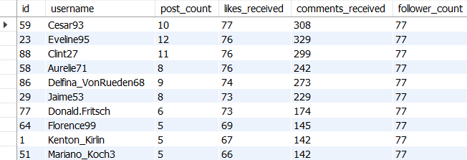
This is the list of ideal users.
RECOMMENDATION:
- Invite high-ranked users to become brand advocates: Reach out with personalized offers, invitations to events, or exclusive initiatives.
- Feature their content and give visibility: Promote their photos or stories in official campaigns.
- Incentivize engagement: Offer rewards, advanced features, or opportunities for co-creation.

Q9. How would you approach this problem, if the objective and subjective questions weren't given?
If only the schema was provided and neither specific objectives nor subjective questions were given, the best approach is to follow a standard analytical and business discovery workflow to uncover relevant questions and solutions.

Step-by-Step Approach
1. Schema Analysis
- Closely examine the schema to understand what entities (tables) and relationships exist.
- Identify which actions, behaviours, or events are captured (e.g., posting, liking, following, tagging, commenting).
2. Feature Identification
- List out the measurable data available: post counts, like counts, comment counts, follower/followee counts, hashtag usage, timestamps, etc.
- Note primary user activities and interactions based on schema.
3. Business Use Case Brainstorming
- Infer the possible business context: Is it social engagement? Content discovery? Influencer identification? Community growth?
4. Formulate Analytical Questions
- Develop meaningful questions the schema can answer. For example:
  - Which users are most active?
  - What content drives the most engagement?
  - Who are key influencers?
  - What hashtags or topics are most trending?
  - Are there patterns in engagement based on time or activity?
5. Define Metrics and Segmentation
- Identify useful metrics: engagement rate, average likes/comments per post, follower growth, etc.
- Segment users/content based on those metrics for deeper insights (active/inactive users, viral content, etc.).

6. Design SQL Queries or Analysis Tools
- For each key question or metric, design the corresponding SQL queries or analytical processes according to the schema.
- Validate and refine the queries to ensure accuracy and coverage.
7. Interpret Results and Surface Insights
- Analyse query outputs to extract actionable insights.
- Visualize trends, distributions, and correlations as needed.
8. Propose Recommendations
- Based on findings, suggest business actions: targeted campaigns, influencer outreach, new feature ideas, or engagement strategies.
- Offer specific data-driven actions for growth, retention, or campaign optimization.

Q10. Assuming there's a "User_Interactions" table tracking user engagements, how can you update the "Engagement_Type" column to change all instances of "Like" to "Heart" to align with Instagram's terminology?
To update all instances of "Like" to "Heart" in the Engagement_Type column of a User_Interactions table, use an SQL UPDATE statement with a WHERE clause:
SQL Query:
UPDATE User_Interactions
SET Engagement_Type = 'Heart'
WHERE Engagement_Type = 'Like';

This command finds all rows where Engagement_Type is "Like" and changes them to "Heart", aligning your data with Instagram's updated terminology.

